**FPT ACADEMY INTERNATIONAL**

**FPT – APTECH COMPUTER EDUCATION**

**32SMILES.COM**

**Center Name** : FPT – Aptech – HCM

**Address** : 590 Cach Mang Thang Tam, District 3, Ho Chi Minh City

**Instructor** : Ms. Le Mong Thuy

**Class** : T1.2110.E1

**Group** : 2

**Group member** : **Name** **Student ID**

Trương Trí Trung Student1345167

Lê Anh Xuân Student1345173

Nguyễn Ngọc Bích Vân Student1345348

Từ Quang Nam Student1345493

**Duration** : Start date 13-Jan-2022

End date 27-Feb-2022

**This is to certify that**

Mr./Ms.:

Trương Trí Trung

Lê Anh Xuân

Nguyễn Ngọc Bích Vân

Từ Quang Nam

**has successfully designed & developed**

eProject: 32smiles.com

**Submitted by:**

Trương Trí Trung

**Date of issue:**

13/01/2022

**Authorized Signature:**

**TABLE OF CONTENT**

FPT – APTECH COMPUTER EDUCATION 1

ACKNOWLEDGEMENT 4

SYNOSIS 4

PROBLEM DEFINITION 5

CUSTOMER’S REQUIREMENT SPECIFICATION (CRS) 6  
Business/Project Object 6  
Hardware/Software Requirements 7

SCOPE OF THE WORK 8

ARCHITECTURE AND DESIGN OF THE SYSTEM 9

DIAGRAM OF THE WEBSITE 10

TASK SHEET REVIEW 1 11

SITE MAP 12

MOCK OF THE WEBSITE 13  
1. Home page 13  
2. Dental health 14  
3. Research 15  
4. Products 16  
5. Contact us 17  
6. Dental clinic 18  
7. FAQ 19

TASK SHEET REVIEW 2 20

WEBSITE DESCRIPTION 21  
1. Home page 21  
2. Dental health 22  
3. Research 23  
4. Products 24  
5. Contact us 25  
6. Dental clinic 26  
7. FAQ 27  
8. Header & Footer 28

TASK SHEET REVIEW 3 29

**ACKNOWLEDGEMENT**

On behalf of all the members of group 2, I would like to thank you all for the hard working, support to make this eProject complete successfully. Especially, Ms. Le Mong Thuy, our teacher, she helped us a lot from the day that we started to study at FPT Aptech. With this eProject, she has guided us with her enthusiasm and rigorous, because of her guiding, we would be able to finish this project. Besides, I want to thank all the member of group 2, each of the member has been working to complete this project. The finally, we would like to say thank you to our family for always supporting us, creating the best conditions for us to focus on the project, and putting faith in the dreams we pursue.

**SYNOSIS**

Today oral health affects our ability to eat, speak, smile, and show emotions. Oral health also affects a person’s self-esteem, school performance, and attendance at work or school. Hence to increase the awareness and provide all information about dental care, we are looking for developing a website “32smiles.com” to teach the community about the importance of oral health and connect them with dental professionals. And we provide policy and programmatic recommendations to improve the oral health of vulnerable populations. At the same time, we also conduct research and release reports documenting oral health care.

**PROBLEM DEFINITION**

The Website is to be created based on following requirements:

1. The Home Page should be created making use of Sections with a suitable logo.
2. The site should display a menu which will contain the options for brief introduction about the various products and service available, location of the clinic location and any other information.
3. The site should display a menu with following categories:

* Home
* Dental health
* Research
* Products
* Contact us
* Dental Clinic
* FAQ

1. When user selects any category, the corresponding content will be displayed.
2. Summary of the features of individual products/services should be detailed, understandable, and specific.
3. Price of Services/Products List should be available for download.
4. There should be a “Contact Us” page which will have the Address of the Company and the mail address which when clicked will invoke the local mail client from where they can send an email. Address of the Company should be displayed using Geolocation API (e.g., Google Maps).

**CUSTOMER’S REQUIREMENT SPECIFICATION (CRS)**

**Client: India Aptech**

**Project Objective:** Increase the awareness and provide all information as well as knowledge about dental health care.

At 32 Smiles, we help the community increase the awareness about the importance of oral health and connect them with dental professionals. At the same time, we also provide policy and programmatic recommendations to improve the oral health of vulnerable populations.

The website is to be developed for the Windows Platform using HTML5, JavaScript, AngularJS, Bootstrap and Geolocation. The site should work well in all leading browsers including Chrome, IE, Firefox etc.

* **Input:**
  + Search for information about oral health as well as information about personal dental care.
  + Ask for advice from a dental professional.
  + Book an appointment.
  + Intensive dental training courses, teaching aids, symposiums, practical research.
  + Dental awareness, FAQs, dental news, necessary information about expression and dental concerns.
  + The latest information, treatment research methods: photos, videos, documents, etc.
  + Information on medical examination, treatment, dental care, dental care products.
* **Output:**
  + A menu that will categorize all the functions of the web.
  + Display a list of products, news, knowledge of customers interested.
  + Perform a search from information of professional or patient education.
  + Images, videos of oral disease.
  + Display geographical location of 32 Smiles.
  + Consulting about dental health for people by Q&A.
  + Form for people to register for an appointment with professional at 32 Smiles.
  + Besides the above requirements, the site should have an industry-standard look and feel.
* **Data processing process:**
  + Products and information filter based on relevant products name or key words.
  + Users can search for products information on the search bar.
  + Authenticate data input from users.
* **Hardware and software requirements:**
  + **For developer:**

**Hardware:**

* + - Intel Pentium 166 or better
    - 64 Megabytes of RAM or higher

**Software:**

* Notepad/HTML editor/VS Code
* Dreamweaver
* IE 5.0/ Netscape 6.0
* Web browsers such as IE, Chrome or Firefox are supporting HTML5, CSS3, JavaScript.
* **For web users:**

**Hardware:**

* Inter Pentium 4 processor or higher
* 512 Megabytes of RAM or higher

**Software:**

* Window XP OS or higher
* Web browsers such as IE, Chrome or Firefox are supporting HTML5, CSS3, JavaScript.
* **Expected delivery date:** 26-Feb-2022
* **List of deliverables:**
  + Document Word.
  + User Guide.
  + Source Code.

**SCOPE OF THE WORK (IN BRIEF)**

After a long and detailed discussion, our group has decided to create a website contain the following webpages:

1. **Home:** Display information about 32 Smile, information of dental disease, solutions, dental products, and dental clinic.
2. **Dental health:** Display the document and information about oral health for student, practitioners and guide dental care for people.
3. **Research:** Display all the latest research in the field: necessary documents, videos (media library), etc.
4. **Products:** Display all products dental care.
5. **Contact us:** Display form contact with 32 Smile to schedule an appointment with a dental care professional. Display location of 32 Smile.
6. **Dental Clinic:** Display all information of dental clinic depend on area and booking service for consultant of oral health.
7. **FAQ:** Display questions of patient and answers of dental care professional.

**ARCHITECTURE AND DESIGN OF THE SYSTEM**

Webpage request

Requested page

WEB BROWSER

WEB SERVER

RENDERING  
ENGINE

Interpretation

Interpretation

**DIAGRAM OF THE WEBSITE**

HOME

DENTAL HEALTH

RESEARCH

PRODUCTS

CONTACT US

FAQ

CONTACT US

**TASK SHEET REVIEW 1**

|  |  |  |  |  |  |  |  |
| --- | --- | --- | --- | --- | --- | --- | --- |
| **Project Ref No.:**  **32SMILES.COM** | | **Project**  **Title** | **Activity**  **Plan**  **Prepared**  **By** | **Date of Preparation of Activity Plan** | | | |
| **No.** | **Task** | **Actual**  **Start Date** | **Actual Days** | **Team**  **Mate Names** | **Status** |
| 1 | Problem Definition | **32**  **SMILES**  **.COM** | **Trung** | 13-Jan-22 | 2 | Van | Completed |
| 2 | Customer’s Requirement Specification (CRS) | 13-Jan-22 | 2 | Xuan + Nam | Completed |
| 3 | Scope of The Work (In Brief) | 13-Jan-22 | 2 | Xuan | Completed |
| 4 | Architecture And Design of The System | 13-Jan-22 | 2 | Trung | Completed |
| 5 | Diagram of The Website | 13-Jan-22 | 2 | Trung | Completed |

|  |  |
| --- | --- |
| **Date: 18-Jan-2022** | |
| Signature of Instructor:  **Ms. Le Mong Thuy** | Signature of Team Leader:  **Truong Tri Trung** |

**SITE MAP**

Home

Dental health

Research

Products

Contact us

Dental clinic

FAQ

Introduction page

Dental health page

The latest research pages

Products page

Toothpaste

Brushes

Electrical accessories

Special products

Contact page

Information of dental clinic page

FAQ page

**MOCK OF THE WEBSITE**

1. **Home page**

HEADER

FOOTER

INTRODUCTION OF 32SMILES.COM

CATEGORIES OF DENTAL DISEASE

SOLUTIONS

CATEGORIES OF DENTAL PRODUCTS

INTRODUCTION OF DENTAL CLINIC

1. **Dental health**

HEADER

FOOTER

CATEGORIES

INTRODUCTION

COURSES

DENTAL PROFESSIONAL RESOURCES

FACULTY RESOURCES

CASE STUDENT

STUDENT RESOURCES

CASE CHALLENGES

1. **Research**

HEADER

FOOTER

FILTER

SEARCH

INFORMATION

ARTICLE

PAGING NAVIGATION

ARTICLE

…

ARTICLE

ARTICLE

1. **Products**

HEADER

FOOTER

RELATED QUESTIONS

INFORMATION

IMAGE

1. **Contact us**

HEADER

FOOTER

SLIDER

CONTACT FORM

TEAM MEMBER

MAP LOCATION

1. **Dental Clinic**

HEADER

FOOTER

SUBNAV

FILTER

ARTICLE

ARTICLE

ARTICLE

ARTICLE

1. **FAQ**

HEADER

FOOTER

BANNER

⮛ QUESTION

ANSWER

⮚ QUESTION

⮚ QUESTION

⮚ QUESTION

⮚ QUESTION

⮚ QUESTION

**TASK SHEET REVIEW 2**

|  |  |  |  |  |  |  |  |
| --- | --- | --- | --- | --- | --- | --- | --- |
| **Project Ref No.:**  **32SMILES.COM** | | **Project**  **Title** | **Activity**  **Plan**  **Prepared**  **By** | **Date of Preparation of Activity Plan** | | | |
| **No.** | **Task** | **Actual**  **Start Date** | **Actual Days** | **Team**  **Mate Names** | **Status** |
| 1 | Site map | **32**  **SMILES**  **.COM** | **Trung** | 18-Jan-22 | 2 | Trung | Completed |
| 2 | Home page | 18-Jan-22 | 2 | Trung | Completed |
| 3 | Dental health page | 18-Jan-22 | 2 | Xuan | Completed |
| 4 | Research page | 18-Jan-22 | 2 | Xuan | Completed |
| 5 | Products page | 18-Jan-22 | 2 | Nam | Completed |
| 6 | Contact us page | 18-Jan-22 | 2 | Nam | Completed |
| 7 | Dental clinic page | 18-Jan-22 | 2 | Van | Completed |
| 8 | FAQ page | 18-Jan-22 | 2 | Van | Completed |

|  |  |
| --- | --- |
| **Date: 20-Jan-2022** | |
| Signature of Instructor:  **Ms. Le Mong Thuy** | Signature of Team Leader:  **Truong Tri Trung** |

**WEBSITE DESCRIPTION**

1. **Home page**
   * 1. **Description**

This webpage displays following information: overview about 32Smiles, brief description of dental health, research, and products as well as some pictures depend on information.

* + 1. **Screenshot**

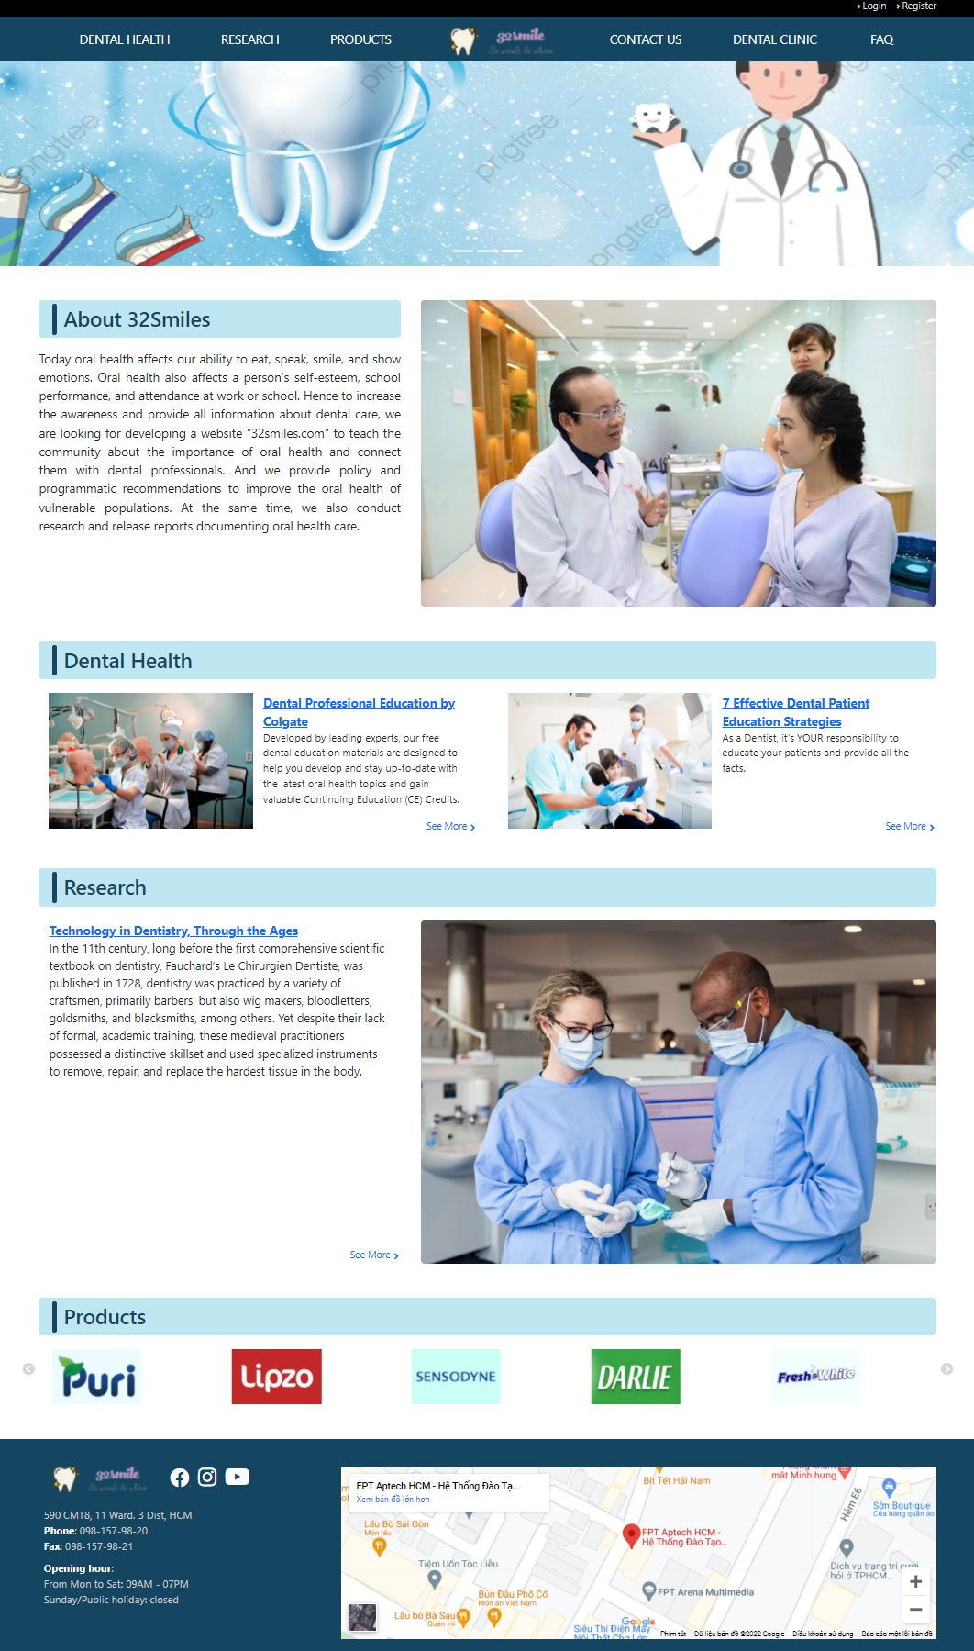

1. **Dental health**
   * 1. **Description**

This webpage displays following information: introduction of professional education, information of courses, dental professional resources, faculty and student resources, case studies and case challenges.

* + 1. **Screenshot**

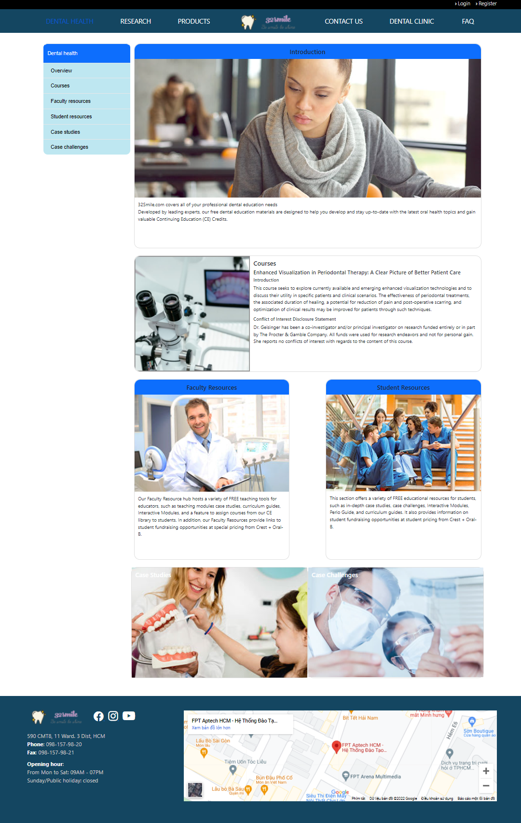

1. **Research**
   * 1. **Description**

This webpage displays following information: the latest research and achievement in the field, necessary documents, media library.

* + 1. **Screenshot**

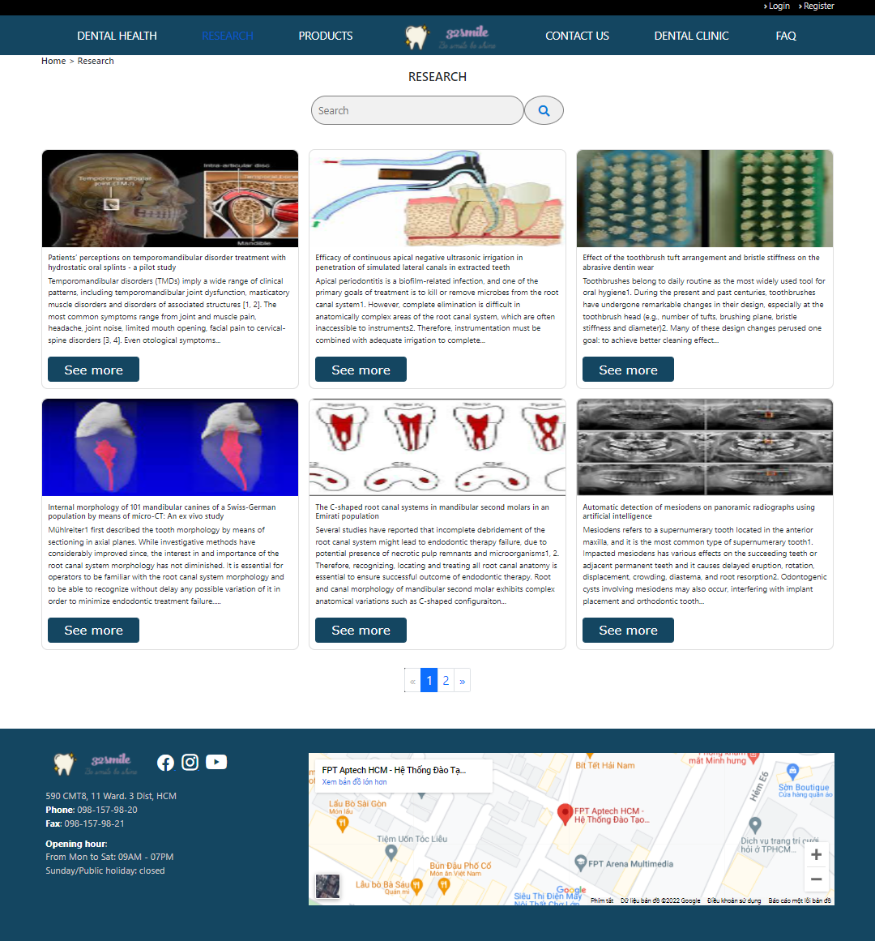

1. **Products**
   * 1. **Description**

This webpage displays following information: various types of dental products such as toothpastes, toothbrushes, special products for kids, electrical accessories.

* + 1. **Screenshot**

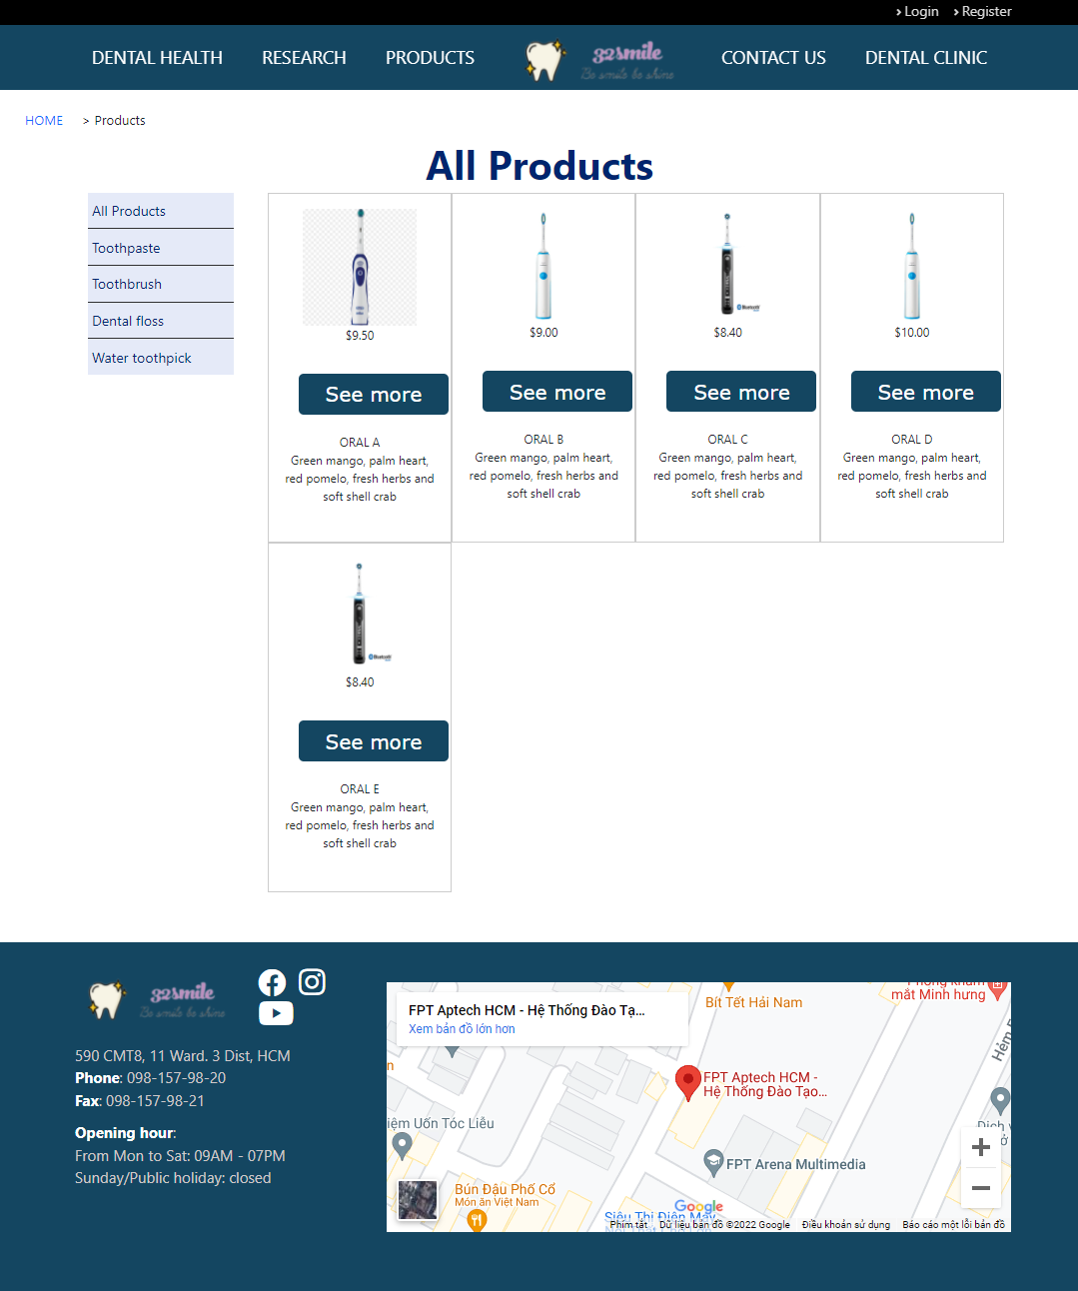

1. **Contact us**
   * 1. **Description**

This webpage displays following information: contact information, address, email, phone number and the form to feedback.

* + 1. 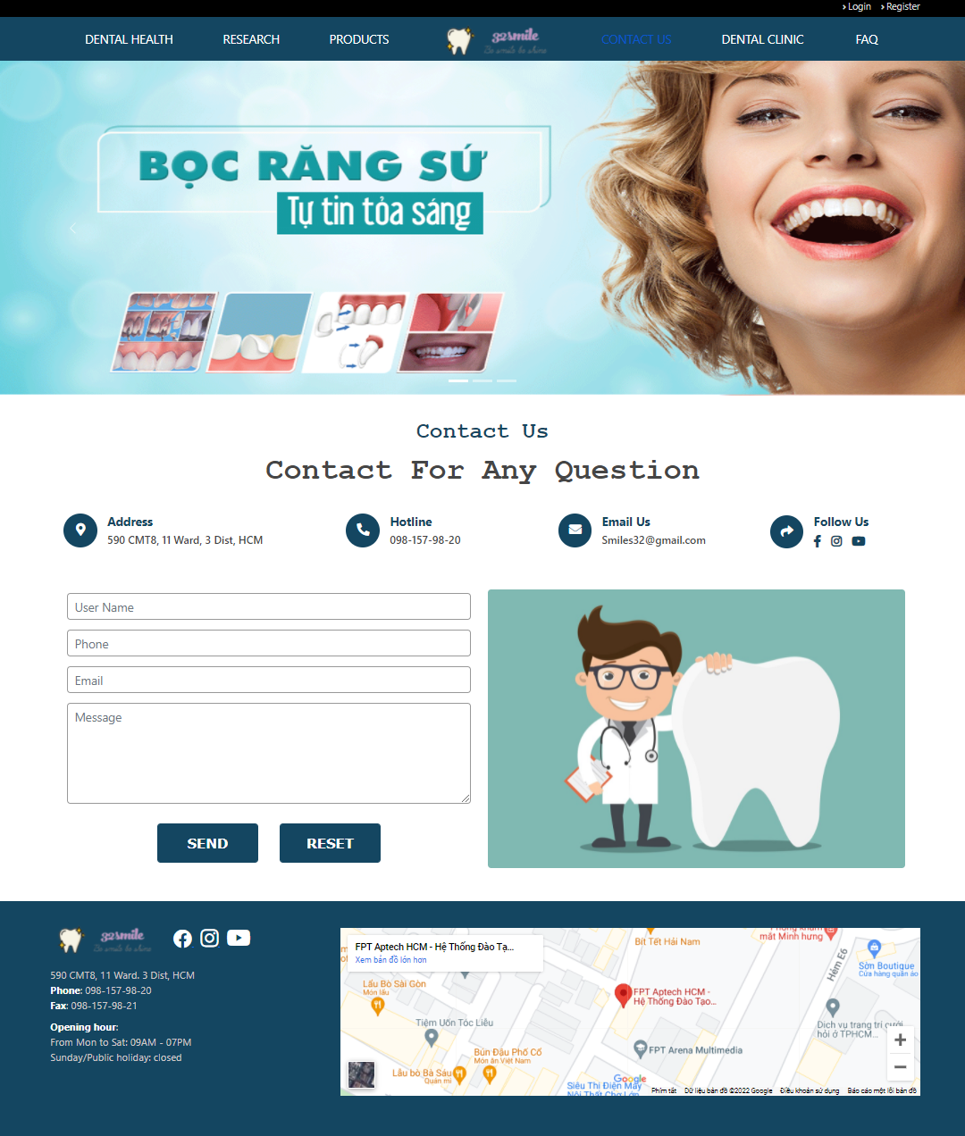**Screenshot**

**Dental Clinic**

* + 1. **Description**

This webpage displays following information: overview, brief description and contact information about dental clinic in area.

* + 1. 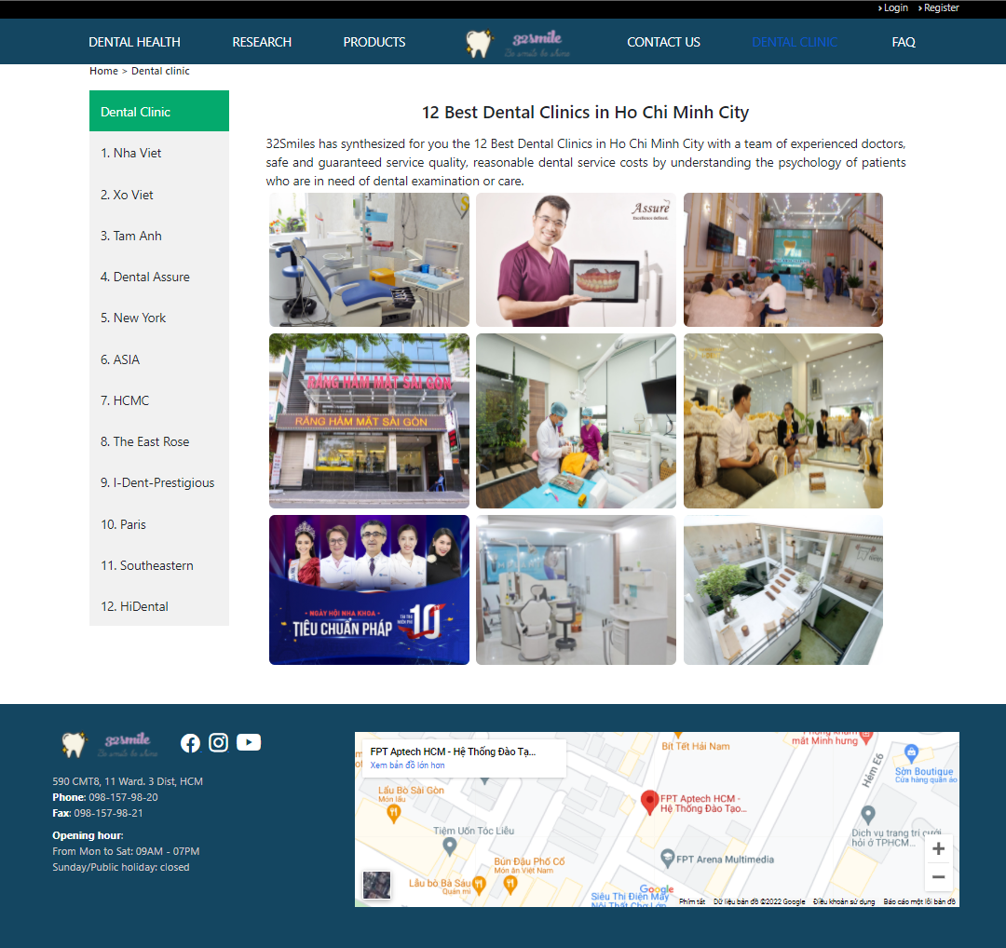**Screenshot**

1. **FAQ**
   * 1. **Description**

This webpage displays following information: frequent question and answer about dental health.

* + 1. **Screenshot**

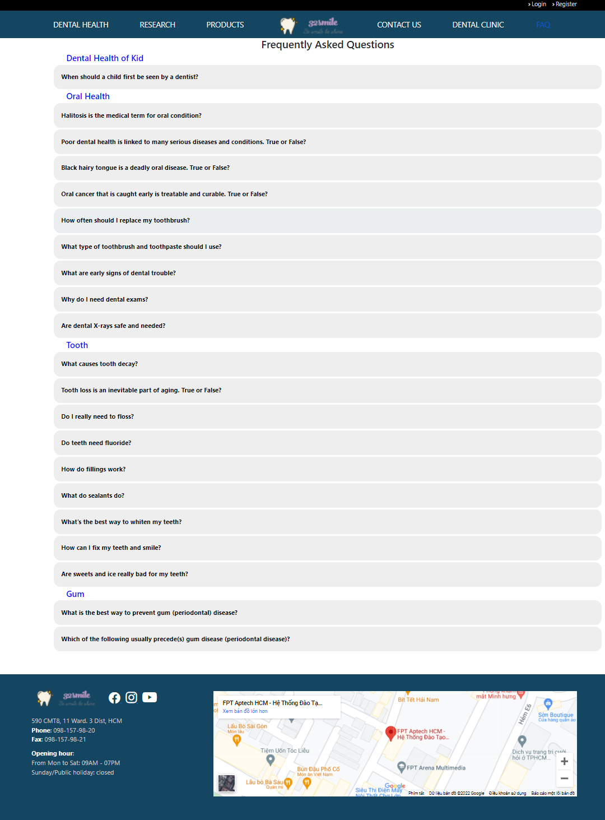

1. **Header & Footer**
   * 1. **Description**

This webpage displays following information:

* Navbar displays the link to another webpage:
  + - Dental health page
    - Research page
    - Products page
    - Logo: Home page
    - Contact us page
    - Dental clinic page
    - FAQ page
* Footer displays:
  + - Logo
    - Contact information
    - Address, phone number
    - Opening hours
    - Map
    1. 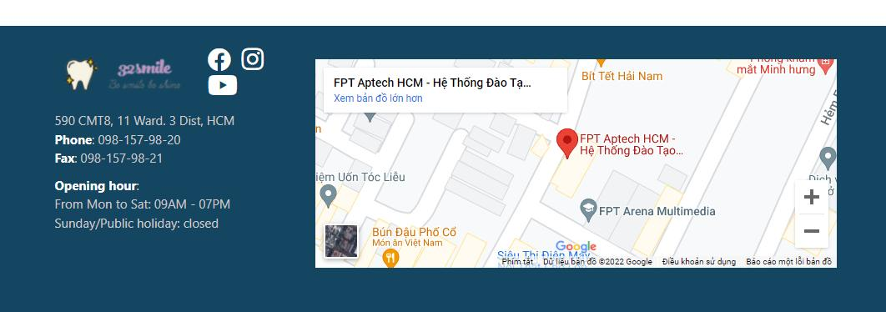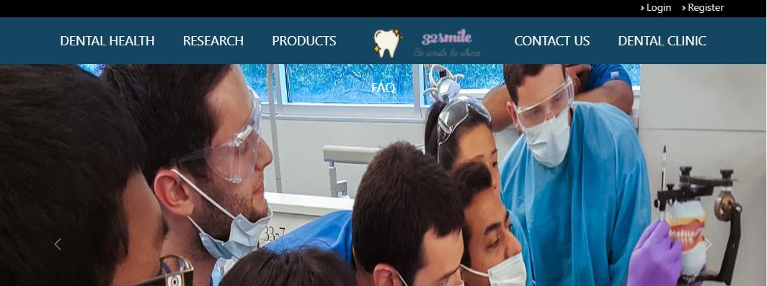**Screenshot**

**TASK SHEET REVIEW 3**

|  |  |  |  |  |  |  |  |
| --- | --- | --- | --- | --- | --- | --- | --- |
| **Project Ref No.:**  **32SMILES.COM** | | **Project**  **Title** | **Activity**  **Plan**  **Prepared**  **By** | **Date of Preparation of Activity Plan** | | | |
| **No.** | **Task** | **Actual**  **Start Date** | **Actual Days** | **Team**  **Mate Names** | **Status** |
| 1 | Home page | **32**  **SMILES**  **.COM** | **Trung** | 22-Jan-22 | 5 | Nam | Completed |
| 2 | Dental health page | 25-Jan-22 | 10 | Xuan | Completed |
| 3 | Research page | 25-Jan-22 | 10 | Xuan | Completed |
| 4 | Products page | 25-Jan-22 | 7 | Van | Completed |
| 5 | Contact us page | 25-Jan-22 | 3 | Nam | Completed |
| 6 | Dental clinic page | 25-Jan-22 | 7 | Trung | Completed |
| 7 | FAQ page | 25-Jan-22 | 10 | Trung | Completed |

|  |  |
| --- | --- |
| **Date: 26-Feb-2022** | |
| Signature of Instructor:  **Ms. Le Mong Thuy** | Signature of Team Leader:  **Truong Tri Trung** |